Project Proposal
Machine-Learning Susceptibility Mapping of Landslides Triggered by the 2015 Gorkha Earthquake, Nepal
Machine Learning Project Assignment
Softwarica College of IT and E-Commerce
Submitted by: Unique Rajak
Proposal date: 28 September 2026 | Project deadline: 11 October 2026

1. Summary
This project will build a machine-learning model that maps where the 25 April 2015 M7.8 Gorkha earthquake was most likely to trigger landslides across 13 districts of central Nepal. It trains on 2,477 co-seismic landslides mapped by ICIMOD, using terrain from a 90 m SRTM DEM, ground shaking from USGS ShakeMaps and bedrock geology.
Four models (Frequency Ratio, Logistic Regression, Random Forest and XGBoost) will be compared using leave-one-district-out validation and tested on an independent inventory from Bahrabise, Sindhupalchok. A second model trained only on 1,857 pre-earthquake landslides will show how earthquake-triggered landslides differ from everyday rainfall-triggered ones.
The output is a susceptibility map and an explanation of its drivers that planners can use for road siting, resettlement and early-warning priorities. The project runs for two weeks, from 28 September to 11 October 2026.

2. Background and Problem Statement
Nepal sits on the Himalayan collision zone, where large earthquakes and steep, weak slopes combine to produce thousands of landslides in a single event. The 25 April 2015 Gorkha earthquake (M7.8, epicentre 28.23°N 84.73°E, depth 8.2 km) and its 12 May M7.3 aftershock near Kodari triggered landslides across central Nepal that blocked roads and rivers and buried villages, most heavily in Sindhupalchok, Gorkha, Rasuwa and Dhading.
Most landslide maps in Nepal are built from rainfall-triggered slides, because monsoon failures happen every year. Earthquake-triggered slides behave differently: shaking is amplified on ridges and steep upper slopes, so they cluster in places a rainfall-based map may rate as safe. Planners therefore lack a map that answers a simple question: if a similar earthquake strikes again, which slopes are most likely to fail?
The problem this project addresses is:
- There is no openly documented, reproducible ML susceptibility model for the Gorkha co-seismic landslides built on ICIMOD’s public inventory.
- It is not known how much a rainfall-era (pre-earthquake) landslide map under-predicts earthquake-triggered failures.
- The relative importance of shaking versus terrain and geology for these landslides has not been quantified with explainable ML on this dataset.

3. Aim, Objectives and Research Questions
Aim: produce an accurate, explainable map of co-seismic landslide susceptibility for the 2015 Gorkha earthquake region, and show how it differs from a rainfall-era landslide map.

3.1 Objectives
- Clean and integrate the ICIMOD 14-district landslide inventory, separating pre-earthquake, main-shock and aftershock landslides by image date.
- Build a feature set from the DEM (elevation, slope, aspect, curvature, relief), USGS ShakeMaps (PGA, PGV) and the Geology of Nepal map.
- Train and compare Frequency Ratio, Logistic Regression, Random Forest and XGBoost classifiers.
- Validate with leave-one-district-out cross-validation and an independent test on the Bahrabise inventory.
- Explain the best model with SHAP and produce a classified susceptibility map (Low, Moderate, High, Very High).
- Compare a model trained on co-seismic landslides with one trained only on pre-earthquake landslides.

3.2 Research Questions
- RQ1. How accurately can ML models predict where the Gorkha earthquake triggered landslides (target ROC-AUC ≥ 0.80 on held-out districts)?
- RQ2. Which factors (shaking, slope, relief, geology, elevation) contribute most, and how do they interact?
- RQ3. How well does a model trained on pre-earthquake landslides predict co-seismic ones, and what does the gap reveal about earthquake-specific hazard?
- RQ4. Does the model transfer to an independently mapped area (Bahrabise, Sindhupalchok)?

4. Study Area and Data
The study area covers 13 earthquake-affected districts of central Nepal (longitude 84.62–86.68°E, latitude 27.00–28.53°N), from the Gorkha epicentre east to Dolakha and Ramechhap. All datasets below have already been downloaded and checked.
Dataset | Source | Format / resolution | Role | Key facts
Landslide data of 14 earthquake-affected districts | ICIMOD RDS (2016) | Polygon shapefile, WGS84 | Target labels | 4,747 polygons: 1,857 pre-earthquake; 1,615 imaged 25 Apr–11 May 2015; 862 imaged 12 May–30 Jun 2015
Gorkha EQ landslides of Bahrabise, Sindhupalchok | ICIMOD / SERVIR (2015) | Polygon shapefile, Everest 1830 MUTM 84, 1:5,000 | External test set | 551 polygons in 5 landslide types
SRTM CGIAR DEM, Nepal | CGIAR-CSI | ERDAS .img, 90 m, int16 | Terrain features | 9,793 × 4,925 px; 58–8,664 m
ShakeMap, main shock (us20002926) | USGS | XML grid, ~1.8 km | Shaking features | M7.8; PGA up to 86.6 %g; MMI max 8.7
ShakeMap, aftershock (us20002ejl) | USGS | XML grid, ~0.9 km | Shaking features | M7.3; PGA up to 58.2 %g
Geology of Nepal | ICIMOD RDS | Polygon shapefile, WGS84 | Lithology feature | 856 polygons, 40+ formations
Table 1. Datasets used in the project
Initial checks already support the approach. The median slope at landslide sites is 34° against 22° across the study area. Median main-shock PGA is 61 %g at co-seismic landslides, 53 %g at pre-earthquake landslides and 51 %g at random points.

5. Methodology
The workflow runs from three inputs to one explained map, with two models trained side by side so their difference can be measured (Figure 1).
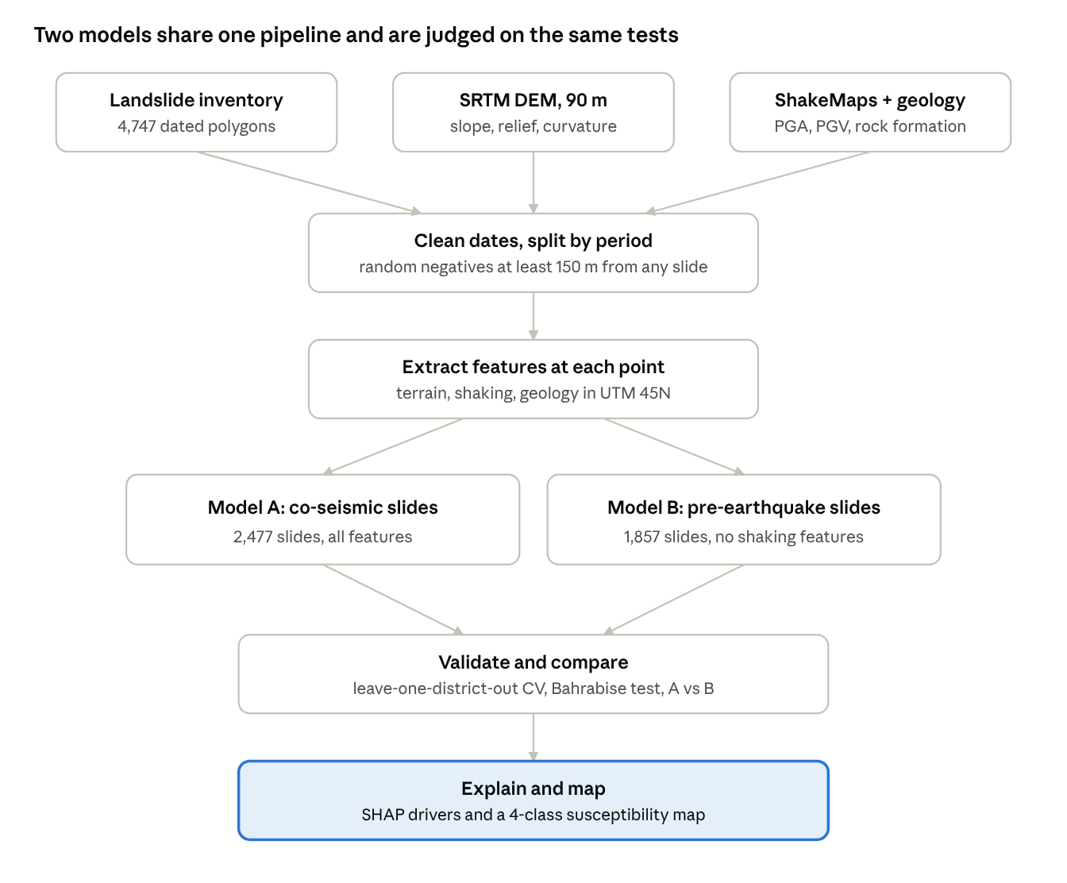
Figure 1. Project workflow: three inputs, two models, one map

5.1 Preprocessing
Parse the image date in each landslide’s Name field (for example "5/3/015" = 3 May 2015) and drop or repair 19 records with unreadable dates. Label landslides as pre-earthquake (before 25 Apr 2015), main shock (25 Apr–11 May) or main shock + aftershock (12 May–30 Jun). Exclude Jul–Dec 2015 and 2016 images, which are likely monsoon failures. Reproject all layers, including the Bahrabise inventory from Everest 1830 MUTM, to UTM 45N, and treat DEM value 0 (outside Nepal) as no-data.

5.2 Sampling
Represent each landslide by one point (its centroid). Draw an equal number of random non-landslide points on valid terrain, at least 150 m from any mapped landslide of any date.

5.3 Features
- Terrain: elevation, slope, aspect (sine and cosine), plan and profile curvature, local relief, topographic wetness index.
- Shaking: main-shock PGA, aftershock PGA, maximum PGA, PGV.
- Geology: rock formation class, encoded with frequency-ratio values computed on training folds only.

5.4 Models
Frequency Ratio as the statistical baseline used in landslide studies, followed by Logistic Regression, Random Forest and XGBoost, with hyperparameters tuned inside the cross-validation folds.

5.5 Explanation and Mapping
Use SHAP to rank features and show how slope and PGA interact. Apply the best model to every 90 m cell and classify probabilities into Low, Moderate, High and Very High susceptibility.

6. Evaluation and Validation
Models are judged on districts and an area they never saw in training, so the scores reflect real prediction rather than memorised neighbours.
Test | How | Answers
Leave-one-district-out CV | Train on 12 districts, test on the 13th, repeat 13 times | RQ1: accuracy on unseen ground
External test | Apply the final model to the Bahrabise inventory (551 slides, different mapper, 1:5,000) | RQ4: transferability
Model A vs Model B | Score Model B (pre-earthquake training) on co-seismic landslides and compare with Model A | RQ3: what rainfall-era maps miss
Explainability | SHAP summary and dependence plots for slope, PGA, relief and geology | RQ2: drivers and interactions
Table 2. Validation design
Metrics: ROC-AUC and PR-AUC (primary); precision, recall and F1 at the chosen threshold; and success-rate and prediction-rate curves, the standard landslide-mapping check of what share of landslides falls in the top 10% and 20% most susceptible area.
Success criteria: ROC-AUC of at least 0.80 on held-out districts, ML models outperforming the Frequency Ratio baseline, and at least 60% of Bahrabise landslides falling in the High or Very High classes.

7. Expected Outcomes and Impact
The project will deliver a validated susceptibility map and a quantified answer to how earthquake landslide hazard differs from everyday rainfall hazard.

7.1 Deliverables
- A reproducible Google Colab notebook covering cleaning, feature extraction, training, validation and mapping.
- A co-seismic landslide susceptibility map of the 13 districts at 90 m, in four classes, exported as GeoTIFF.
- A model comparison table (FR, LR, RF, XGBoost) and SHAP plots of the main drivers.
- The Model A vs Model B analysis, including a map of where the rainfall-era model under-predicts earthquake hazard.
- A final report and presentation.

7.2 Real-World Use
- Planning and prevention: flags slopes to avoid for new roads, hydropower access routes, schools and resettlement sites.
- Emergency response: after a future earthquake, combining this model with the new ShakeMap can point rescue and road-clearing teams to the most likely failures within hours.
- Early warning: High and Very High zones can guide where to place slope monitoring and community warning systems.
- Policy evidence: shows whether hazard maps built only from monsoon landslides are enough for earthquake preparedness in Nepal.

8. Timeline
The work fits in two weeks, from 28 September to the 11 October 2026 deadline. Data collection is already complete, so the plan starts with cleaning.
# | Phase | Dates (2026) | Output
1 | Proposal submitted | 28 Sep | Approved proposal
2 | Data cleaning and sampling | 28–30 Sep | Labelled landslide and non-landslide points
3 | Feature extraction | 1–2 Oct | Feature table (terrain, shaking, geology)
4 | Model training and tuning | 3–5 Oct | FR, LR, RF and XGBoost models
5 | Validation and Model A vs B | 5–7 Oct | CV scores, Bahrabise test, comparison
6 | SHAP and mapping | 7–8 Oct | SHAP plots, susceptibility map
7 | Report and slides | 8–11 Oct | Final report and presentation
8 | Final submission | 11 Oct | Submitted project
Table 3. Two-week work plan
To fit two weeks, optional features (distance to rivers, roads and faults) and a 30 m DEM upgrade are out of scope unless time is left after validation.

9. Tools, Limitations and Risks

9.1 Tools
Python in Google Colab with GeoPandas, Rasterio, Shapely and PyProj for spatial processing; scikit-learn, XGBoost and SHAP for modelling; Matplotlib for figures; QGIS for map layout.

9.2 Known Limitations
- Landslide dates are Google Earth image dates, not failure dates, so the pre-earthquake set depends on when imagery was available.
- The 90 m DEM cell (~8,100 m²) is larger than the median landslide (~3,500 m²), which smooths slope values.
- ShakeMap grids are coarse (0.9–1.8 km) and modelled rather than measured at most points.
- The inventory covers 13 districts, not the 14 in its title, and Sindhupalchok holds about 30% of all landslides.
- The geology map has a "No Data" class and some undocumented abbreviations; Bahrabise landslide-type codes are also undocumented.

9.3 Risks and Mitigation
Risk | Mitigation
Spatial autocorrelation inflates scores | District-grouped cross-validation, never a random split
Negatives accidentally sampled on unmapped landslides | 150 m buffer from all landslides of any date; test 1:1 and 1:3 ratios
Sindhupalchok dominates training | Report per-district scores; test class weighting
Data leakage through encoding | Fit geology encoding and scaling inside each fold only
Local machine lacks GIS libraries | Run all processing in Google Colab
Two-week deadline is tight | Core features only; optional layers added only if time allows
Table 4. Risks and mitigation

9.4 Ethics and Data Licences
All data are public and non-personal. ICIMOD RDS data are used under CC BY 4.0 or SERVIR terms with attribution; USGS products are public domain. The map is a research product, not an official hazard zonation, and will be labelled as such.

10. References

Data sources (accessed September 2026)
- ICIMOD (2016). Landslide data of 14 earthquake affected districts of Nepal. Regional Database System. rds.icimod.org/metadata/5e19b3a6-910e-4537-a49e-bce2e5da2e78
- ICIMOD / SERVIR-HKH (2015). Nepal’s Gorkha Earthquake 2015 induced landslide data of Bahrabise, Sindhupalchok. rds.icimod.org/metadata/1b4f293a-c131-415f-8e39-a58d2e8bae23
- ICIMOD. Geology of Nepal. Regional Database System. rds.icimod.org/metadata/e0e362b7-0da2-46b3-9323-f301d3b281b5
- USGS (2015). M7.8 Nepal earthquake, event us20002926, ShakeMap grid. earthquake.usgs.gov/earthquakes/eventpage/us20002926
- USGS (2015). M7.3 Nepal aftershock, event us20002ejl, ShakeMap grid. earthquake.usgs.gov/earthquakes/eventpage/us20002ejl
- USGS. ShakeMap. Earthquake Hazards Program. earthquake.usgs.gov/data/shakemap
- CGIAR-CSI. SRTM 90 m Digital Elevation Model, version 4.

Literature
- Kargel, J. S. et al. (2016). Geomorphic and geologic controls of geohazards induced by Nepal’s 2015 Gorkha earthquake. Science, 351(6269).
- Roback, K. et al. (2018). The size, distribution, and mobility of landslides caused by the 2015 Mw7.8 Gorkha earthquake, Nepal. Geomorphology, 301.
- Breiman, L. (2001). Random forests. Machine Learning, 45.
- Chen, T. and Guestrin, C. (2016). XGBoost: A scalable tree boosting system. Proceedings of KDD 2016.
- Lundberg, S. M. and Lee, S.-I. (2017). A unified approach to interpreting model predictions. Advances in Neural Information Processing Systems 30.

